TRAINER'S MANUAL

KAREN TEACHER WORKING GROUP
3rd Edition

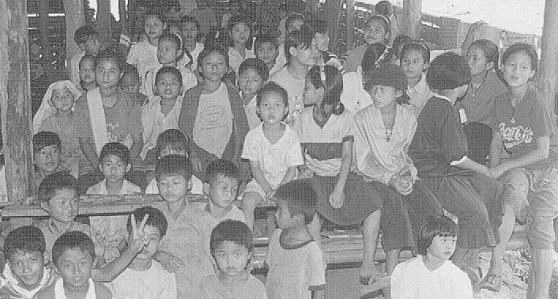
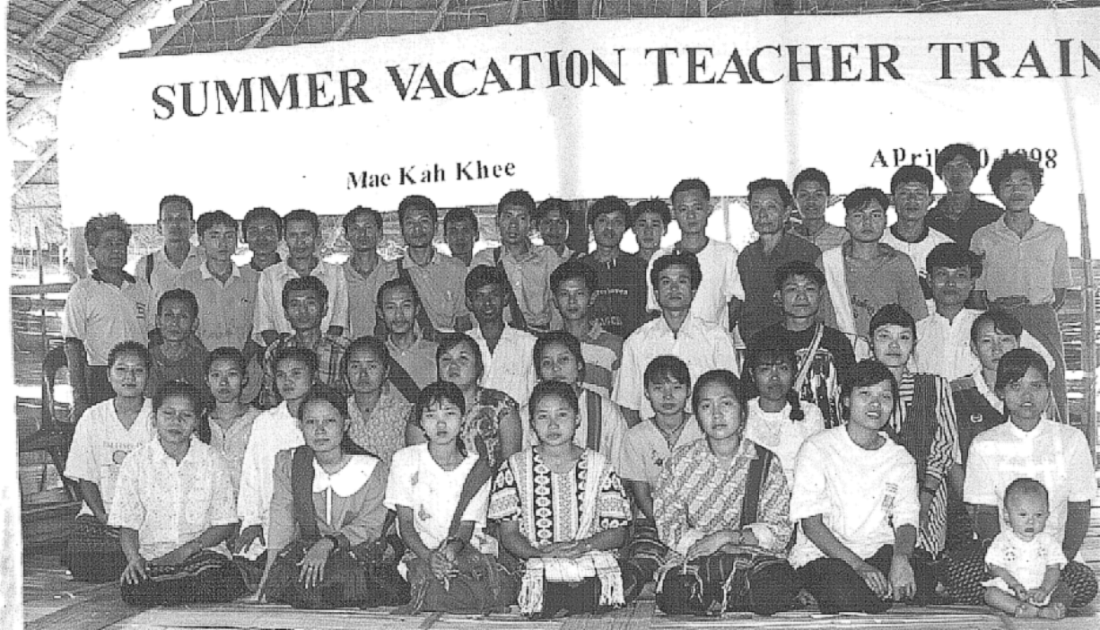
FUNDED BY THE INTERNATIONAL RESCUE COMMITTEE

TRAINER'S MANUAL

KAREN TEACHER WORKING GROUP
3rd Edition



Project Office:
P.O. Box 39
Mae Sariang, Mae Hong Song
58110
Thailand

email teaching@cscoms.com

tel/fax 66-53-681-440

http://members.cscoms.com/~teaching

FUNDED BY THE INTERNATIONAL RESCUE COMMITTEE

K'Ser Doh Leu A Lu Khaw

K'Lo Doh Leu A Lu Khaw

Htaw Daw Pbeu K'Yaw K'Yaw
Htaw Daw Paw K'Yaw K'Yaw

Htaw Htaw Mae Pu A Lu Khaw
Hsu Nya Mu Leh Tdeu Leh Htaw
- Karen 'Htah' (Poem)

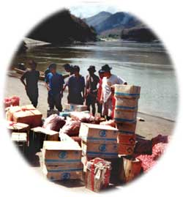

O Great mountain steep and high.
Upwards struggle! We must try!
Climb it with the one you love.
Hand in hand, you climb above.
Climb until problems surpassed.
Days of joy will everlast!

TABLE OF CONTENTS

Preface |  |  | I
Organization of Materials |  |  | II
Overview for the Trainer |  |  | III-VIII
Section1: Educational Psychology |  |  | 1
 | Topic 1: Child as Learner |  | 3
 | Topic 2: Areas and Stages of Child Development |  | 11
 | Topic 3: Learning Styles (Individual Differences) |  | 25
 | Topic 4: Language Acquisition |  | 39
 | Topic 5: Teacher as Decision Maker |  | 49
Section 2: Lesson Planning |  |  | 61
Section 3: Writing Objectives |  |  | 79
Section 4: Classroom Management |  |  | 95
 | Topic 1: A Personal Classroom System |  | 97
 | Topic 2: Alternatives for Managing Student Behavior |  | 105
 | Topic 3: Determining When to Intervene |  | 115
 | Topic 4: Classroom Discipline |  | 123
Section 5: Lesson Presentation |  |  | 143
Section 6: Questioning Skills |  |  | 161
 | Topic 1: An Introduction |  | 163
 | Topic 2: 6 Categories of Questions |  | 169
 | Topic 3: 4 Strategies to Increase Student Response |  | 187
Section 7: Teaching Methods |  |  | 195
 | Topic 1: An Introduction |  | 197
 | Topic 2: Teaching Methods for the Classroom |  | 205
Section 8: Evaluation |  |  | 219
 | Topic 1: 4 Stages in the Evaluation Process |  | 221
 | Topic 2: Writing Good Tests |  | 229
 | Topic 3: Grading |  | 243
Section 9: School and Community |  |  | 253
REFERENCES |  |  | 267

PREFACE

This teacher training package has been developed by Karen, Burman and Canadian educators in Karen, Burmese and English languages. The 2nd Edition is a work in progress, an unfolding dialogue between individuals and groups interested in improving education in refugee camps along the Thai-Burma border and in villages throughout Karen State. The package is meant to accomplish three goals:

- To provide an alternative to texts and training programs available which could be used by schools without outside expertise.

- To use effective strategies for adult learners to promote:
- awareness of educational theory and practice
- self improvement and change

- To provide a teacher training package which can be used by all Karen and Burman trainers and teachers, not only those who have fluency in the English language.

The material presented uses strategies for enhancing skill development by maximizing participant involvement and offering specific procedures for classroom use. The training package concists of 2 components: 1) the Trainer's Manual and 2) the Teacher's Handbook.

The Trainer's Manual contains step-by-step directions for the teacher trainer as well as content information, task sheets, self-analysis activities, and all other materials required to facilitate training workshops.

The Teacher's Handbook includes all materials required for individual and group activites during a training workshop.

Organization of Materials

The content of the Teacher Training Package has been divided into 9 sections:
- SECTION 1: Educational Psychology
- SECTION 2: Lesson Planning
- SECTION 3: Writing Objectives
- SECTION 4: Classroom Management
- SECTION 5: Lesson Presentation
- SECTION 6: Questioning Skills
- SECTION 7: Teaching Methods (general)
- SECTION 8: Evaluation
- SECTION 9: School and Community

Sections have been further divided into specific topic areas. Some sections have up to 5 topic areas while others have only one. Each topic will require 1-3 days of training to complete (depending on the size of the topic, the teacher trainer, and the trainee group).

To help trainers and trainees to use this package, each type of material is identified by one of the following labels and contains the type of material described below.

- Topic Summary
Contains the topic title, goals, a brief description of the content included and a listing of the materials included in the topic area.
- Trainer's Guide
Contains step-by-step directions for the trainer. Also includes answers to task sheets and group activities.
- Content Reading
Provides information about specific topic area.
- Task Sheet
Provide directions for learning activities to be completed individually, or in groups.
- Group Activity
Provides instructions for group activities.
- Self-Analysis Activity
Provides instructions for trainees to individually examine classroom practices and personal behavior.
- Case Study
Provides an imaginary situation to which trainees must respond to, using newly acquired knowledge or skills. Provides example of how a concept or strategy can be used in the classroom.
- Trainer's Helper
Provides extra content information and gives suggestions to the trainer.

The Trainer's Manual contains all of the above. The Teacher's handbook contains everything except for the Trainer's Guide and the Trainer's Helper.
TYPES OF TRAINING

You have all at one time participated in some kind of training. It might have been a teacher, leadership, political, health or any other type of training. The following is a comparison between two general types of training: conventional and participatory.
(The following chart has been adapted from Manual for Training of Trainers: Society for Participatory Research in Asia.)

Conventional Training | Participatory Training
In conventional training, a trainee is looked upon as an empty bottle to be filled up by the trainer. In this methodology, the trainer decides what is to be taught and how to teach it. This approach to training believes that the trainer knows everything and the trainees know nothing. The trainer decides what the trainees need to learn and how these learning needs will be met. Trainees maintain a passive role during the entire learning process. In this type of training, trainees' role in their own learning process is minimal.  Because of this basic belief, this training type does not allow trainees to actively participate and gives total control over the process to the trainer. Everything in this type of training, from beginning to end, is done by the trainer alone. Everything depends on the trainer. So one can say it is a trainer-centred approach. | Participatory training believes that people cannot be developed, they can develop themselves through their own actions.  This training type encourages trainees to see themselves as a source of information and knowledge about the real world. Particpatory training refuses to accept that people do not know anything: it recognizes the value of popular knowledge and encourages people to particpate in their own learning process. When encouraged to work from their own experience, people can develop strategies together to change their immediate situation. The process of learning during participatory training is controlled by the participant, not by the trainer.  Trainees begin to recognize and value their existing knowledge. As a result, they are more open to seeking new knowledge, creating new knowledge through the experience and actions of the group.  The first step of participatory training is to create an understanding that change and improvement is possible. The second step, is to enable individuals and groups to identify what types of change they wish to achieve and how to go about attaining that.
ADULT LEARNING | THE LEARNING CYCLE
Often people consider adults as fully developed; meaning that they no longer are able to learn or change. We sometimes hear people say things like, "These men and women (adults) will never learn – and never change. Leave then alone!"  Experience  Experimentation  Reflecting  Theorizing  Learning Experience  Confidence to take on more responsibility  Practice  Learning Experience  Adults Learn. Adults Grow. Adults Change.  This is contrary to the belief that once people have learned something it is difficult to change and that learning is only for children and adolescence. The following are some main principles for adult learning:  - Adults can and do learn throughout their lifetime.  - Adults enter learning activities with a perception about themselves and how they learn. This perception is based on their past experiences.  - Past experiences of adults need to be valued and encouraged through the learnng process. Otherwise, adults might feel worthless or threatened.  - Adults learn best when the environment is safe, accepting, challenging and supportive.  - Adults enter learning activities/training with immediate and personal needs, problems, feelings, hopes and expectations. Their immdediate feelings must be respected and recognized.  - Solutions that adult learners seek must come from their own understanding and analysis, and must make sense in their lives.  - Success in satisfying the expressed learning needs and achieving goals is an important motivation for future learning. Learning activities/ trainings should include lots of possibilities for such success.  - Learning creates several emotional feelings in adults – excitement, tension, confusion, fear, frustration, etc. These feelings, if ignored, could hurt the learning process.  - Different adults learn differently. The variety of learning styles of adults means that many learning options should be available to adults.  Adult Learning is best facilitated in an atmosphere which:  encourages people to be active encourages openness and respect  promotes and facilitates the individual's discovery of personal meaning  recognizes people's right to make mistakes is a cooperative process  accepts differences encourages friendships with other adults | If we are learning all of the time, it would be easy to believe that learning is a straight line, heading in one direction. The fact is the learning process is a circular process which goes on and on, repeating the same stages again and again, always increasing skills and knowledge.  OR
Training Strategy: Small Group Work
A Definition: Small group work places individuals in a setting that encourages reliance on other people (building trust), individual responsibility to the group, cooperation and analysis of and reflection on material to be learned.

Strategy Characteristics | How to use this strategy | When to use this strategy | Changing the strategy
- Groups of 2-6 people  - Groups interact to complete a particular task  - For groups to work effectively, the trainer should encourage:  - Group reliance ('We all must work together')  - Individual responsibility to the group ('I am responsible to do my share of the work')  - Group analysis and reflection ('What did we accomplish?' 'Is there any way we can work better together next time?')  - The trainer observes and gives feedback on the groups' performance | - Trainer presents subject or topic and states expected outcomes.  - Trainer explains directions for the group and expectations for individuals.  - Trainees divide into groups (groups may be chosen by trainees or by the trainer).  - Groups work on their task.  - Trainer monitors groups and encourages them but does not interrupt the group's process.  - The trainer alone, or with the entire group, gives feedback to each small group. | - To establish trust in a risk-taking situation  - To maximize problem solving situations  - To help giving and receiving feedback  - To encourage clear and positive communication  - To encourage participation by everyone. The trainer is able to observe trainees skill development in a non-threatening way  Pairs: interviews, intimate sharing, practicing skills, a quick way to 'waken' the group  3's: getting everyone thinking and participating actively, testing a new idea that trainees' might be to shy to do in front of whole group  4's-6's: more variety of ideas and sharing, good for planning | - Simple Pairs: Match trainees in pairs quickly to review material or come up with quick responses  - Expert Groups: One member from each group forms a new group to master a certain aspect of a new skill. They return to the original group and teach that particular skill to everyone. This is repeated by each group member.
Training Strategy: Brainstorming
A Definition: The process of brainstorming encourages creative thought by sharing ideas. During brainstorming people must know that their ideas and feelings will not be judged by others in the group.

Strategy Characteristics | How to use this strategy | When to use this strategy | Changing the strategy
To be effective brainstorming should include:  - small groups (however large groups can be used to have people quickly think about a new concept or topic)  - an understanding of the criteria and rules of the brainstorming  - building consensus on 3 'best' ideas  - large group sharing of ideas  - analysis of how effective the brainstorming process was | - Form small groups or use whole group (for introduction of new idea)  - Decide on criteria and rules for the brainstorming:  - Write down all ideas  - Let ideas flow as you think of them  - add on to other's ideas  - do not judge or ridicule others' ideas  - be comfortable with silences because they are part of the process  - review, discuss and decide upon the 'best' 3 ideas  - Begin brainstorm.  - Make class list from each groups' brainstorm  - Discuss each groups' brainstorming process | - to generate ideas of how a new topic can be used in the classroom  - to generate different ways to solve problems  - to introduce a new concept or idea  - to reenergize a tired group  - to practice consensus building  - to generate examples of many different teachers' experiences | - have trainees, individually, brainstorm a list of ideas and then have them brainstorm a list of ideas in a group (compare the two experiences in terms of creativity and personal satisfaction)

Time: 15 minutes per brainstorm; 5-10 minute discussion
Number of participants: 2-8(sometimes more), depending on the topic
Materials Needed: blackboard or large paper
Evaluation: small group reflection or large group sharing

Training Strategy: Role Play
A Definition: A creative experience where individuals or groups act out a real life situation. Role play is used to experience or practice using a new skill or observing the effect of certain behaviors.

Strategy Characteristics | How to use this strategy | When to use this strategy | Changing the strategy
- A purposefully developed situation  - Self-created roles in the situation  - Observation by trainees of the role play  - Discussion and feedback | - A situation is chosen (the situation might be a particular problem that teachers are facing or something that allows trainees to practice a new skill).  - Individual roles are decided by trainees (individual or groups) or by the trainer.  - If trainer decides role play, each trainee is given specific information about the role he/she will play.  - Trainees act out their roles while audience observes.  - Audience and role players analyze the role play.  - What did we experience?  - What could have worked more effectively?  - What would you change in the situation? | - To help trainees look at their own behavior as teachers.  - To encourage trainees to share their experiences and feelings.  - To look at how new skills might function in the classroom.  - To give and receive feedback in a non-threatening way.  - To practice new skills by using them. | Small groups can create role plays and then have the role plays acted out by other groups.

Training Strategy: Closure Activities

A Definition: Trainer provides a statement or asks a few short questions to help trainees reflect on, review or respond to newly acquired information. The trainer helps trainees bring new knowledge and experience 'together'.
Strategy Characteristics | How to use this strategy | When to use this strategy | Changing the strategy
- Trainer provides a statement or question that requires trainees to think about what has been learnt.  Example:  "The student behavior that I get most upset with is…"  or  "An appropriate teaching method for Standard 3 on a very hot day is…" | - Trainer saves a little time for this strategy after introducing each new idea or concept; or at the end of an activity, game, or role play.  - Trainer provides a statement or question that requires trainees to think about what they have learnt or experienced.  - Trainer can choose to:  - ask for quick responses from each of the trainees (trainees can choose not to respond)  - ask trainees to answer questions in their handbooks  - ask small groups to discuss and answer the questions | - to make sure that trainees have understood new learnings and experiences | - trainer keeps a list of activities used and their effectiveness

